# Programming tasks

In all cases before you start keying in code, make sure you have an adequate description of the program you intend to write, stating any assumptions that you are making. You should also have pseudo code and/or a flow chart for the problem and a test plan.

## London tube station names containing al 5 vowels (aeiou)

You have a file which contains a list of the London tube stations

Design and write a Python program which will print out the names of all of the stations which contain all 5 vowels (aeiou). The order in which they occur is not important neither are repeated vowels.

## Tied teams at the Rio Olympics

You have a file which contains the final medals table from the Rio Olympics.

Design and write a Python program which will tell you which teams were in a tied position.

For example, the first tied position in the table shows;

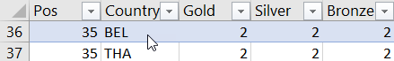

Each line of your output should look something like this:

BEL,THA Tied in position 35 with 2 Golds, 2 Silver and 2 Bronze medals

## Ranking for new medals system at Rio Olympics

1. In the Olympics one Gold beats any number of Silvers or Bronzes. Supposing we introduced a points based system where by a country got 3 points for each Gold, 2 for a Silver and 1 for a Bronze. Create a new points based table for the Rio Olympics based on this system using Pandas and write the results out to a file. The new table should retain the old position field.
2. Write a Python program which reads the new Rio points table and adds a new column indicating whether or not each country was better off under the points system

## Alternative medals table

In the Olympics one Gold medal is worth more than any number of Silver and Bronze medals. So at Rio, Argentina has a higher position in the medals table than Denmark, despite Denmark have far more Silver and Bronze medals.

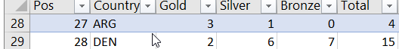

Under an alternative scoring system, points are associated with the medals.

3 points for a Gold

2 points for Silver and

1 point for Bronze

Using this scoring system, design and write a Python program to create a new medals table based on this system. That is the team with the most points should be first.

You may want to use the pandas module for this.